|  |
| --- |
|  |
| Drive Smart **User Manual**  Android Mobile Application User Guide |
| |  | | --- | | **Team – Not Yet** | |

**Contents**

**Preface1**

About this guide2

Audience3

**Overview of the App4**

**Installing the app**5

**Program** **Workspace**6

Home page6

Manuals 7

General Quiz8

My Car9

Start learning10

Practice11

Take Quiz12

Special Scenarios13

Learn 14

Take a quiz15

Common Rules16

Learn road signs17

Common Rules18

Take a Quiz19

**The End** 20

**Preface**

**About This Guide**

This document provides information about the functions available within the Drive smart Android app.

**Preface**

**Audience**

This guide is to be used by people who want to use the Drive Smart app on their Android phone to learn about driving, and some rules about driving in addition to the user’s state dmv manual provided in the app, at their convenience.

**Overview of the App**

The Drive Smart Android App allows you to learn and quiz yourself on common driving knowledge you should be aware of as a current or prospective driver. The app is designed to be easy to use so you should be comfortable with its straightforward navigation functionality.

**Installing the App**

To install the app

Go to <https://github.com/meadowsd13/drivesmart-public>

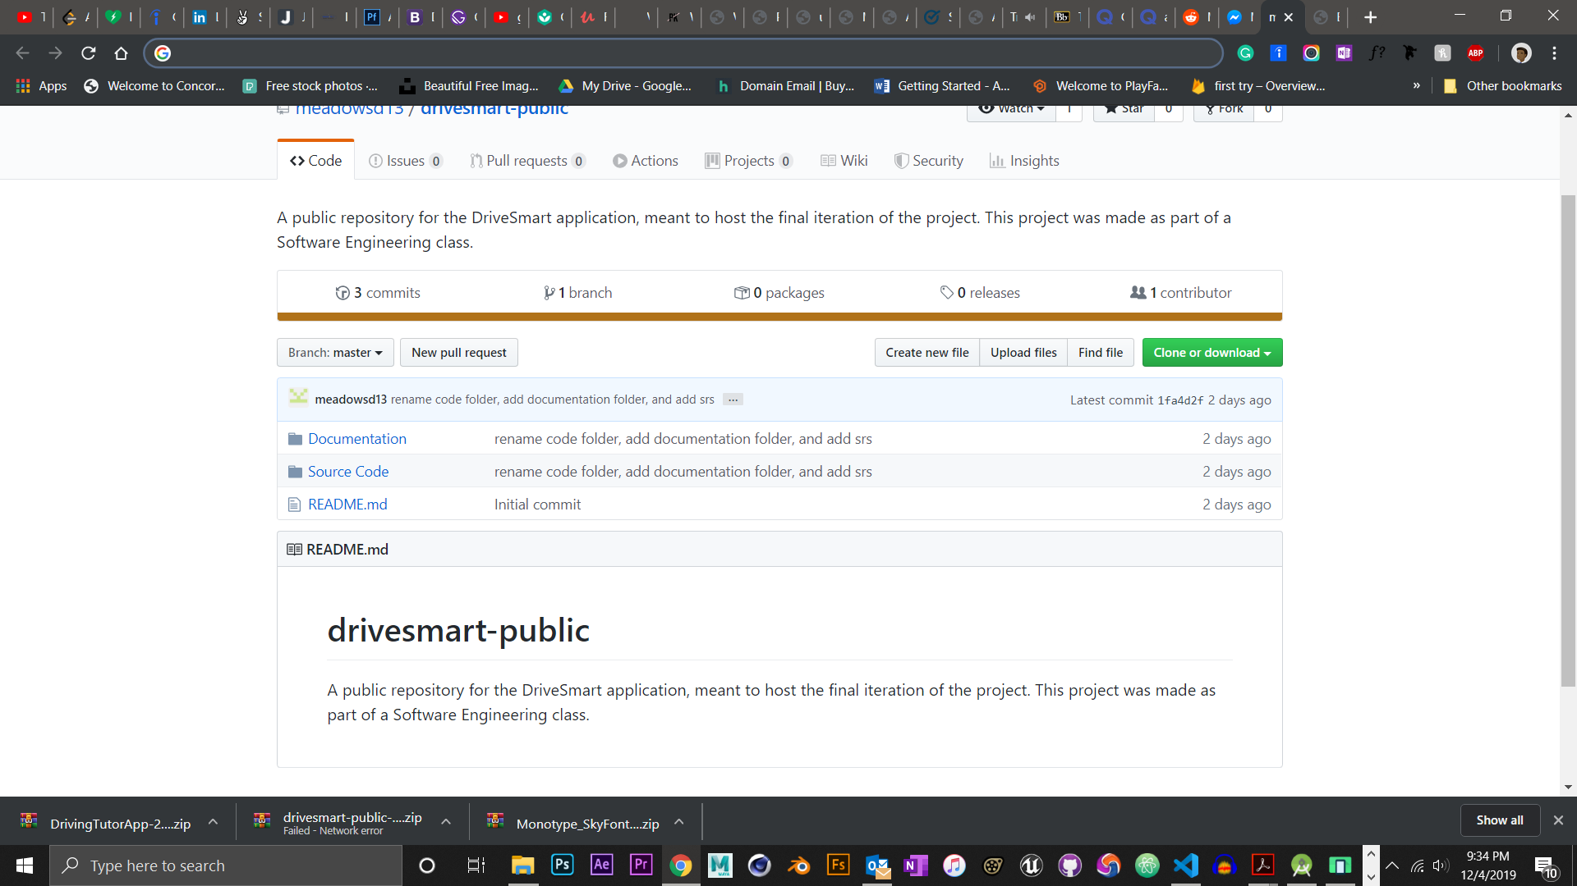

It is currently not on the Google Play Store, hence further changes/versions of the app would be in the GitHub directory listed above.

**Program Workspace**

**-Home page**

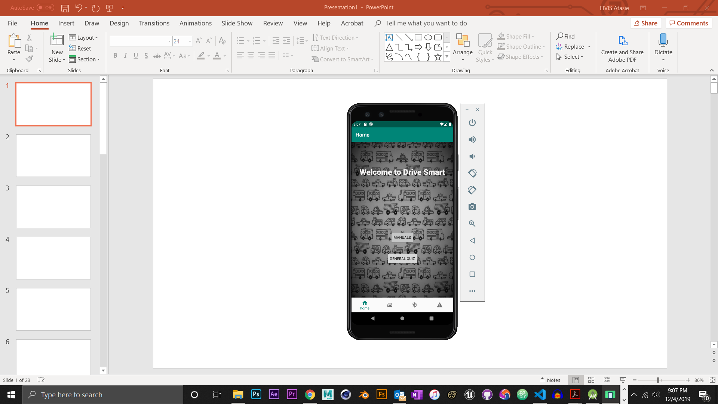

Text indicating

what page on the

app you are on

Options

Welcome text

The first page you seen upon opening the app

App navigation

Back Navigation

*(device displayed is a Google Pixel 3)*

**Program Workspace**

**-Home page**

**-Manuals**

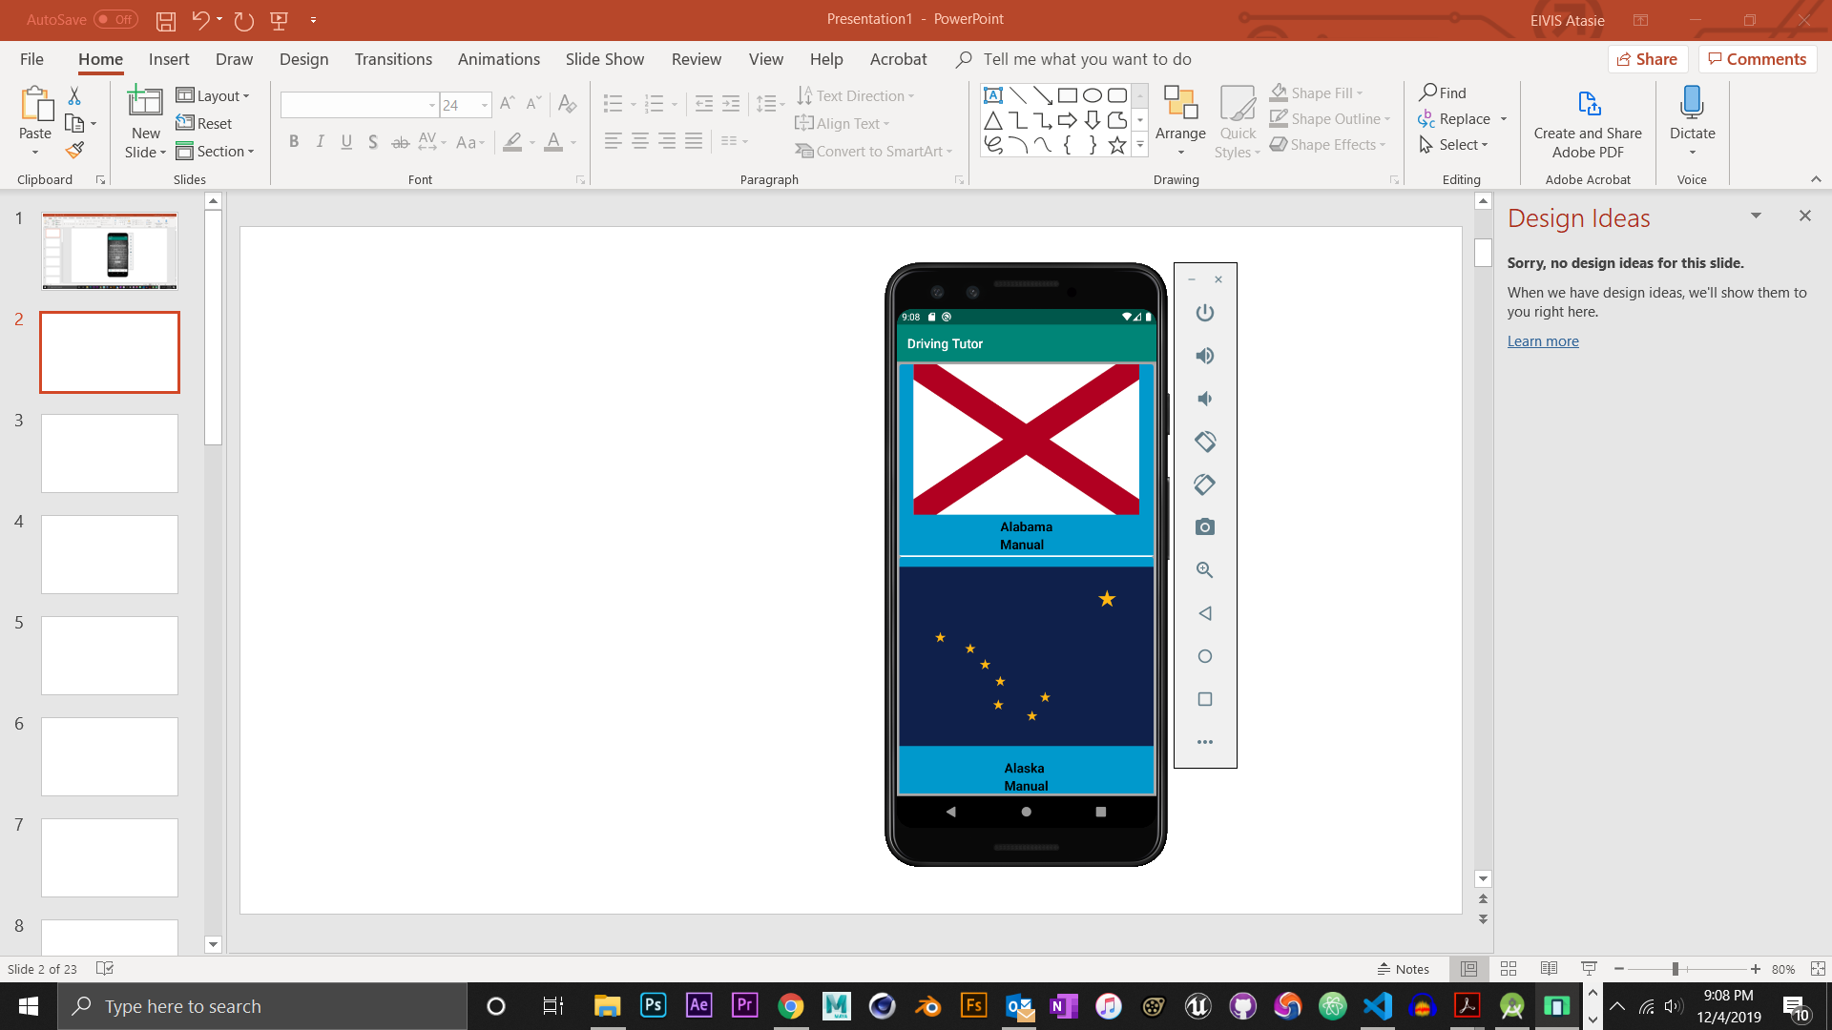

You scroll down to find the DMV manual of the state you are in.

*(device displayed is a Google Pixel 3)*

**Program Workspace**

**-Home page**

**-General Quiz**

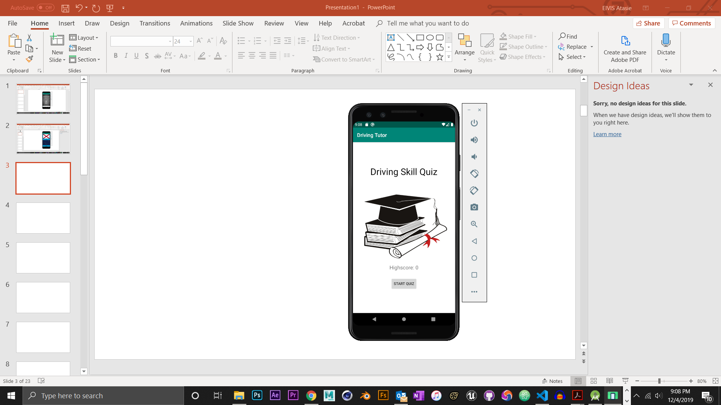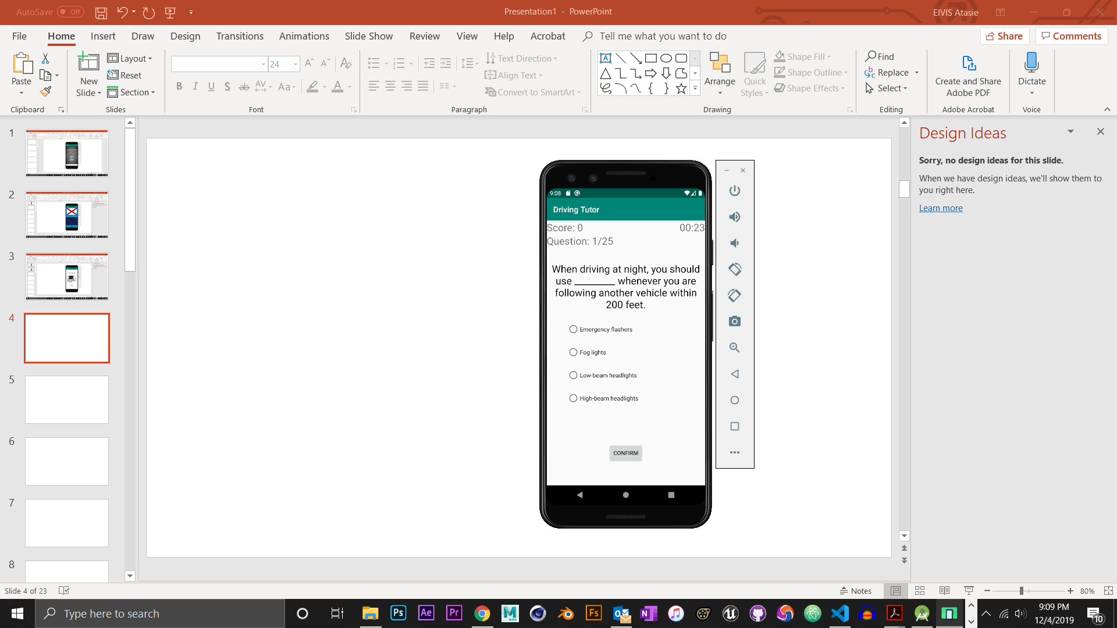

You tap on the right answer and tap on the confirm button to check your answer

A 30 second timer for each question

Click on the ‘Start Quiz’ button to move on to the next screen (“ ”)

Your highscore will be displayed after completing the 25 questions in this Quiz.

*(device displayed is a Google Pixel 3)*

**Program Workspace**

**-My Car**

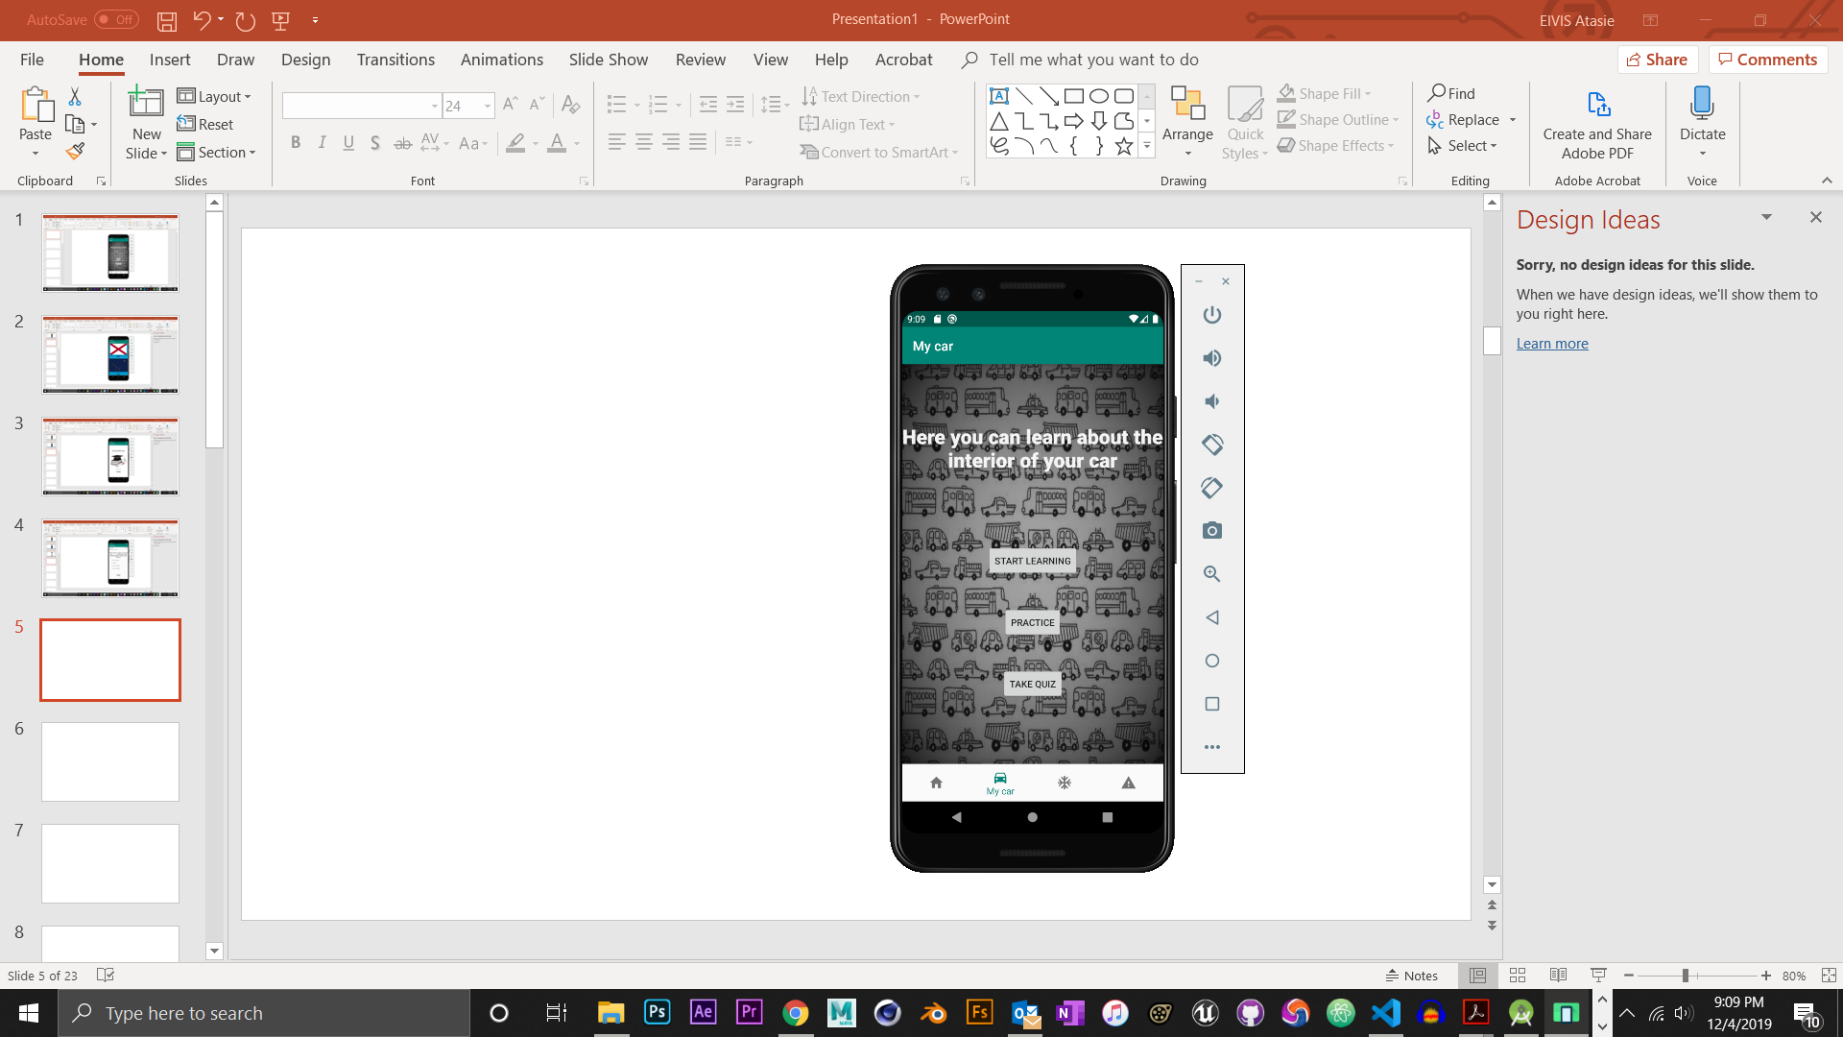

The landing page when you click this button

*(device displayed is a Google Pixel 3)*

**Program Workspace**

**-My Car**

**-Start Learning**

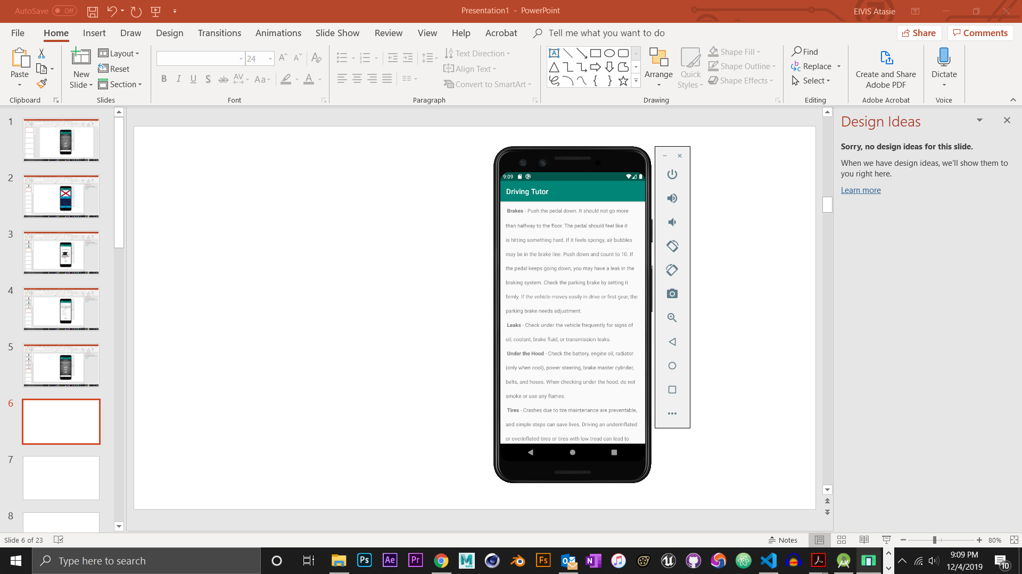

Here is the

learning section

for the

My Car section.

This is where you learn

about different

parts of your car.

*(device displayed is a Google Pixel 3)*

**Program Workspace**

**-My Car**

**-Practice**

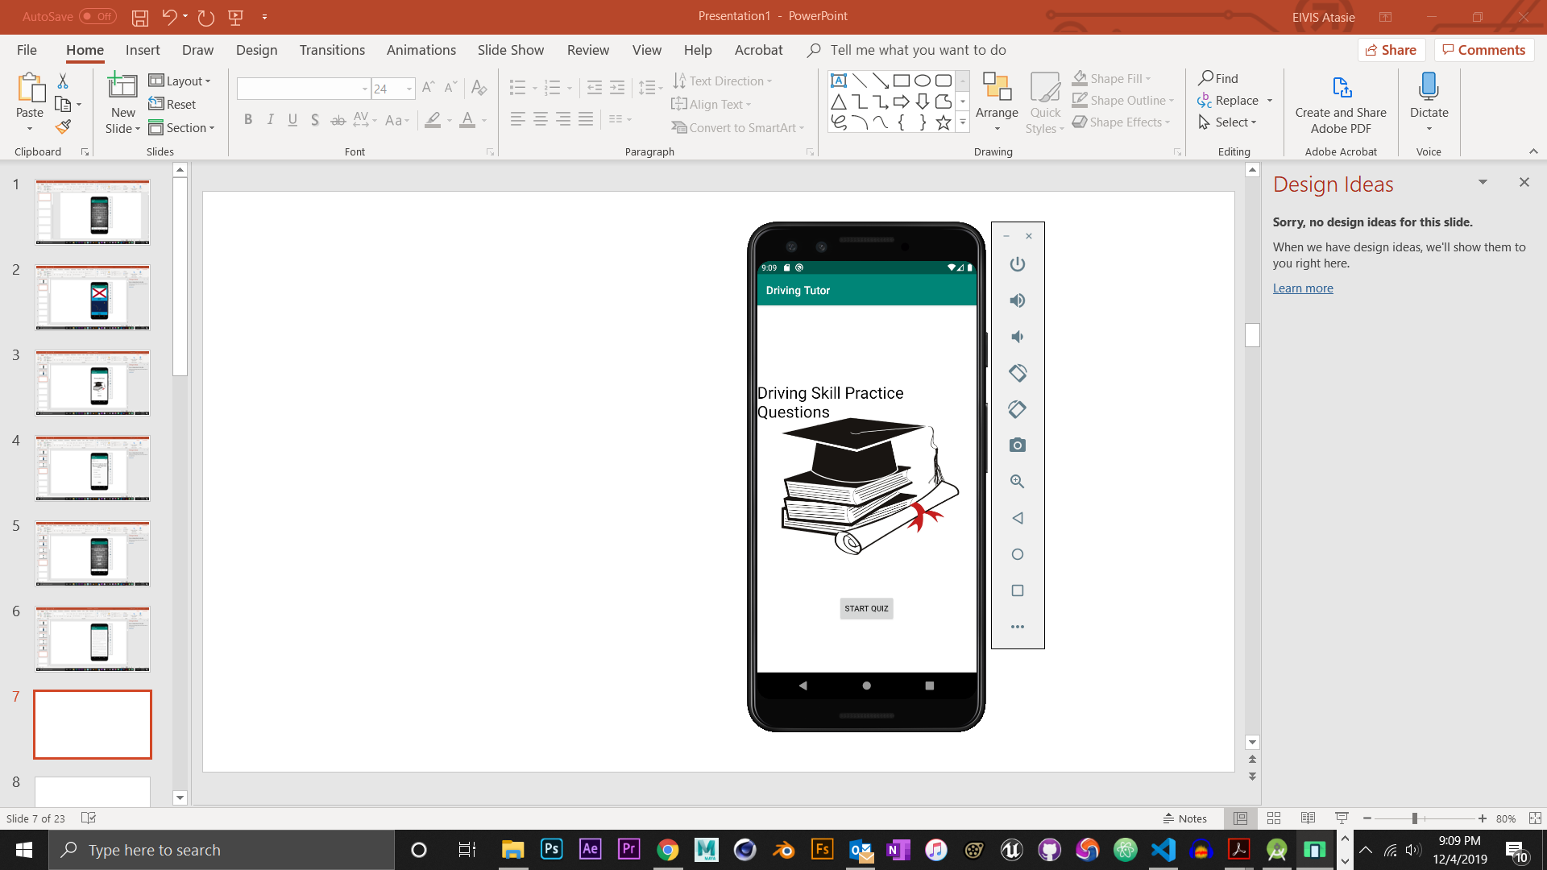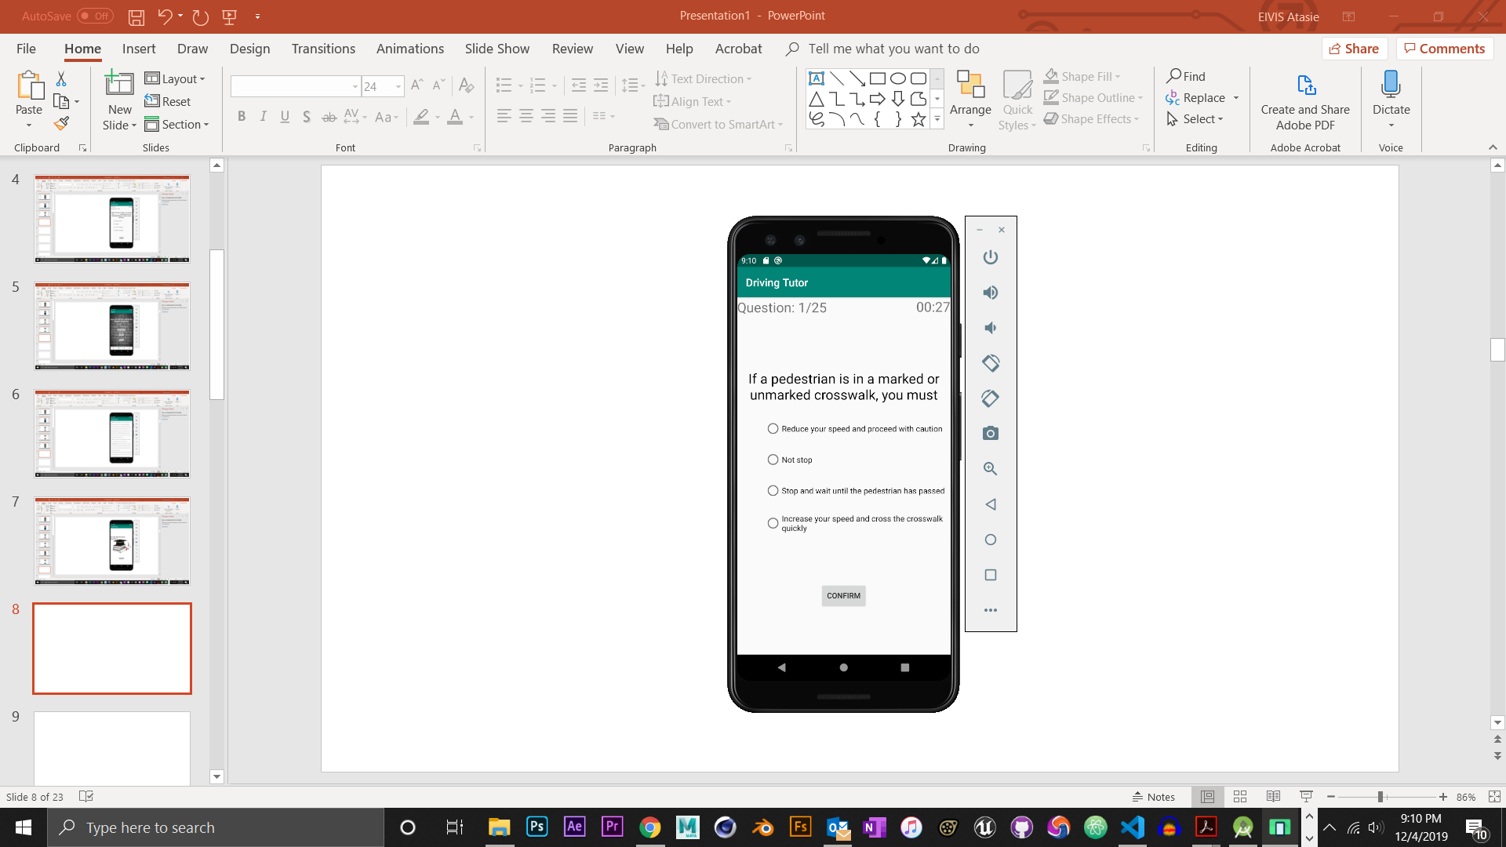

Here you would be tested with 25 Questions from the information you read in learning section previous to this section. Think fast, you only have 30 seconds per question!

*(device displayed is a Google Pixel 3)*

**Program Workspace**

**-My Car**

**-Take Quiz**

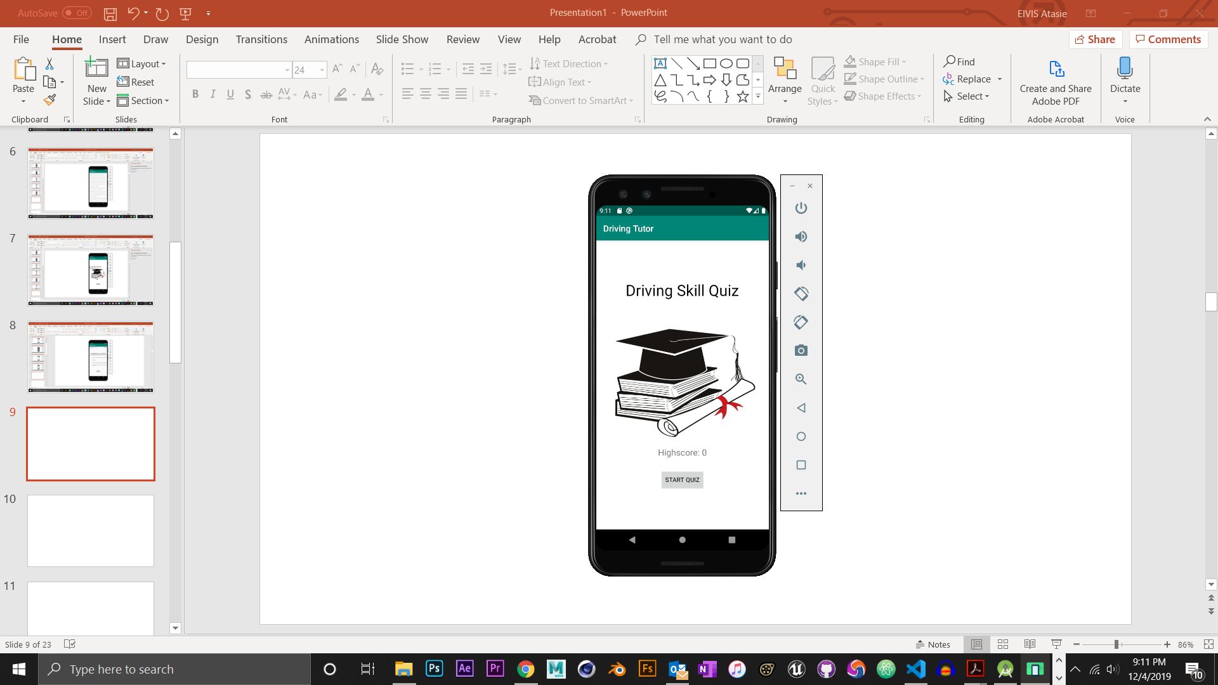 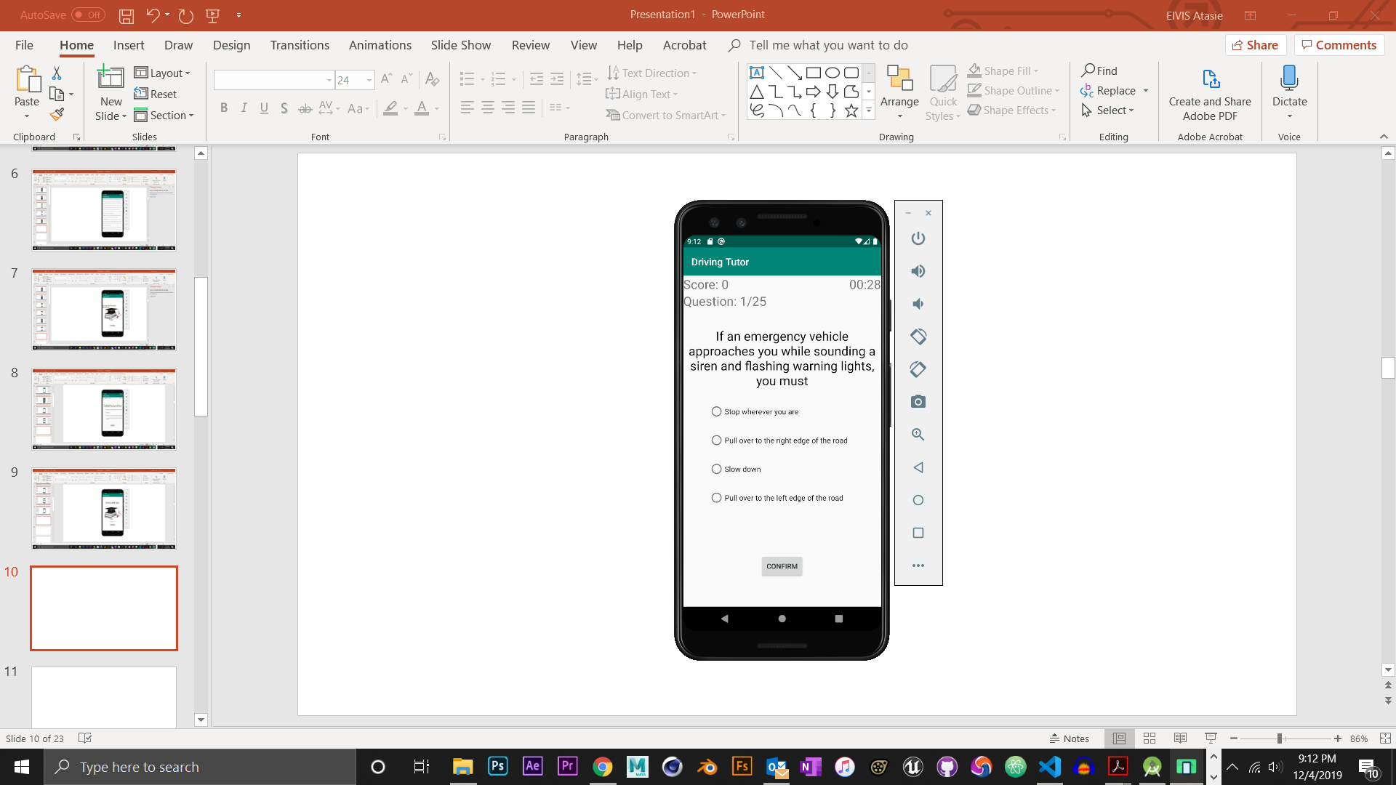

Here you would be tested with 25 Questions from the information you have read so far.

30 seconds per question timer

*(device displayed is a Google Pixel 3)*

**Program Workspace**

**-Special Scenarios**

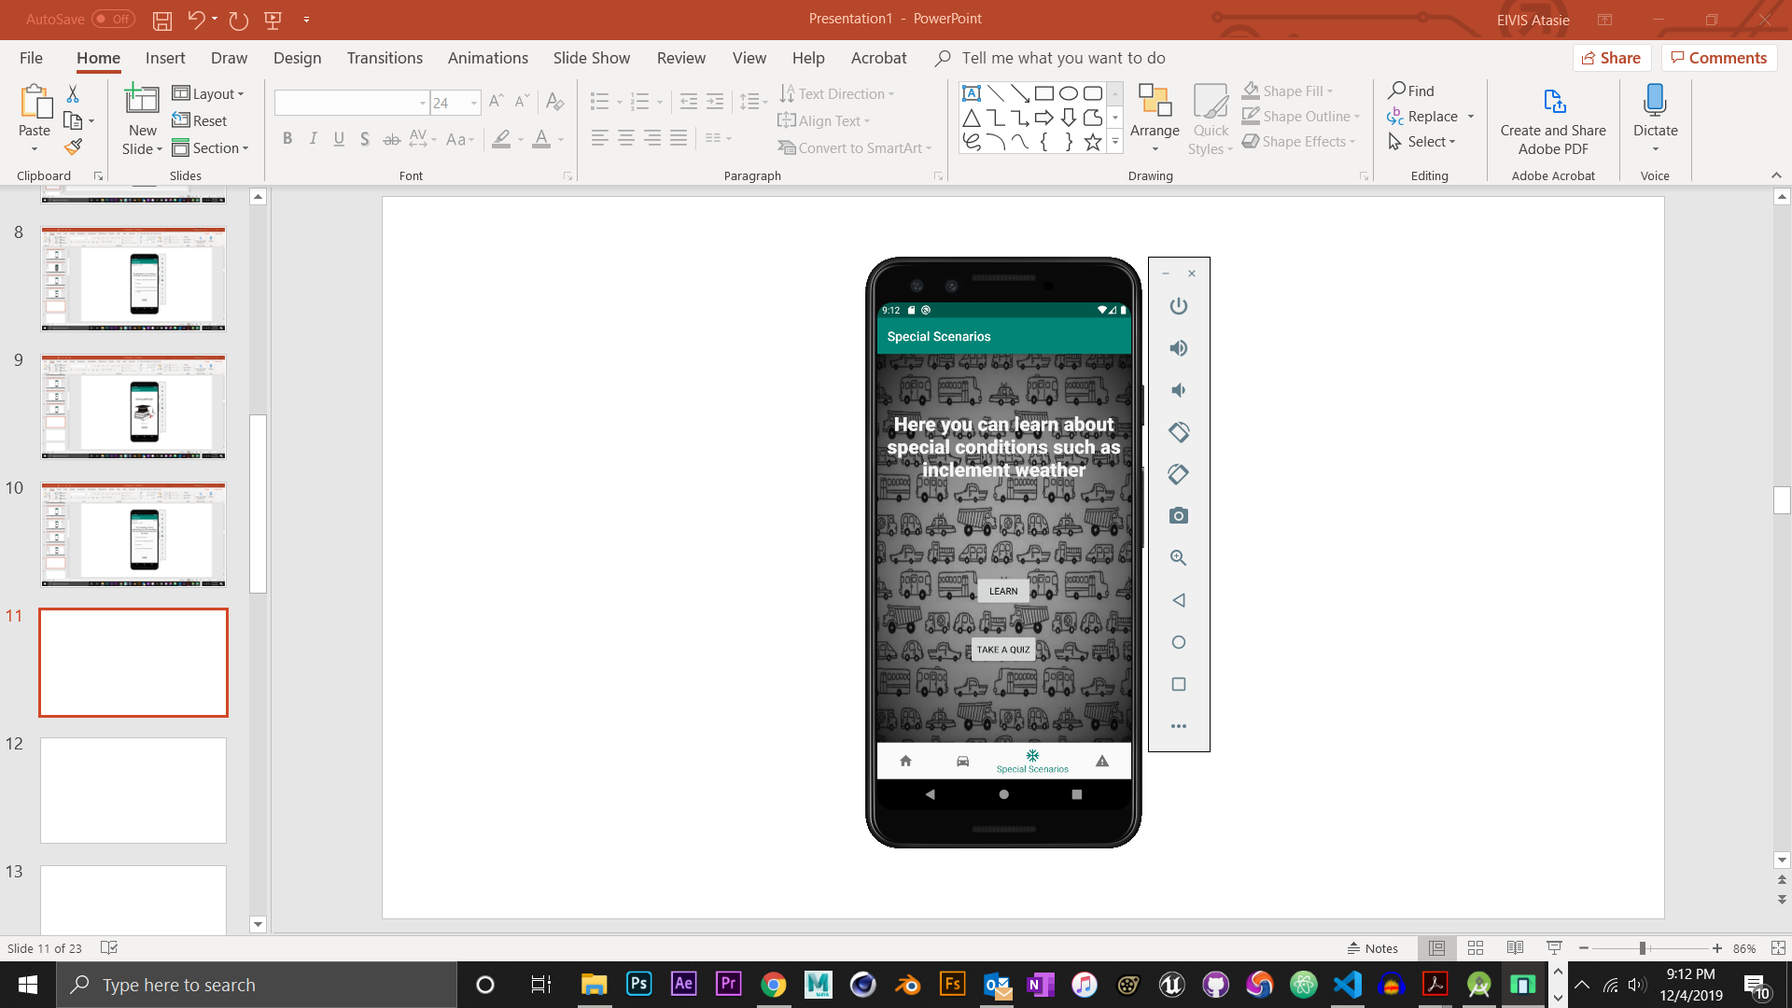

*(device displayed is a Google Pixel 3)*

**Program Workspace**

**-Special Scenarios**

**-Learn**

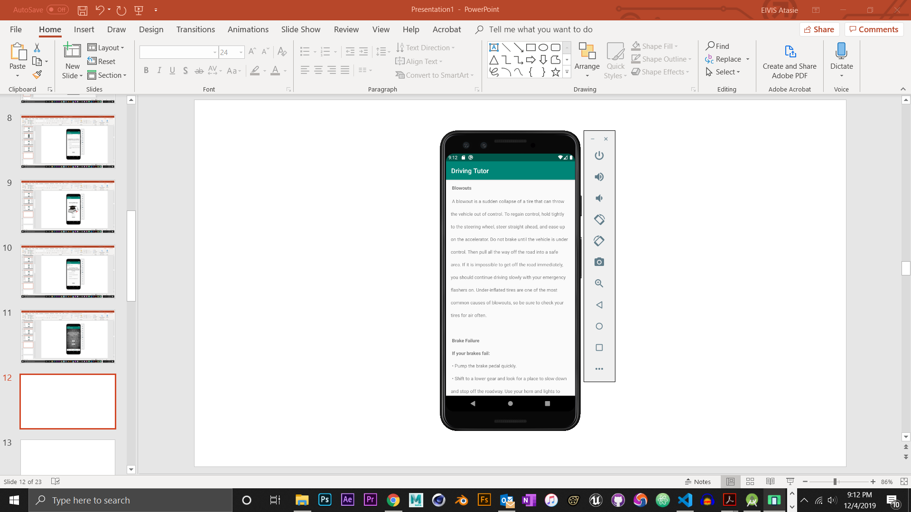

*(device displayed is a Google Pixel 3)*

**Program Workspace**

**-Special Scenarios**

**-Take a Quiz**

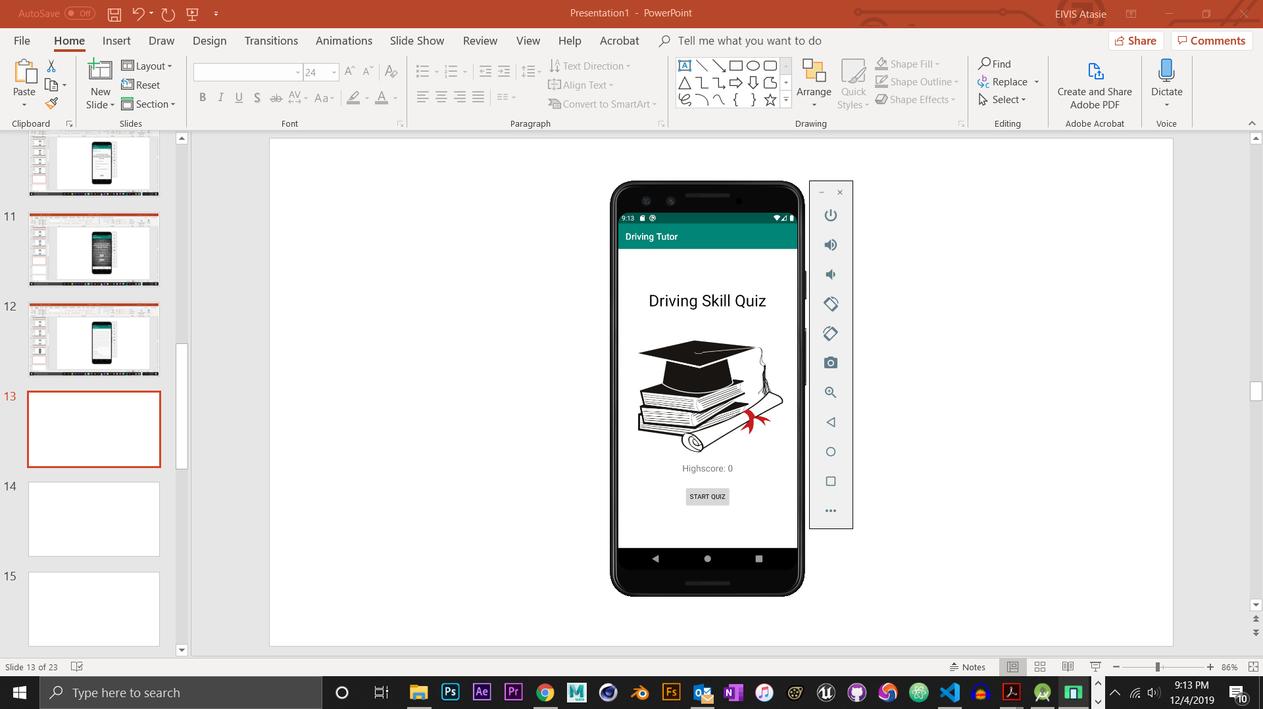 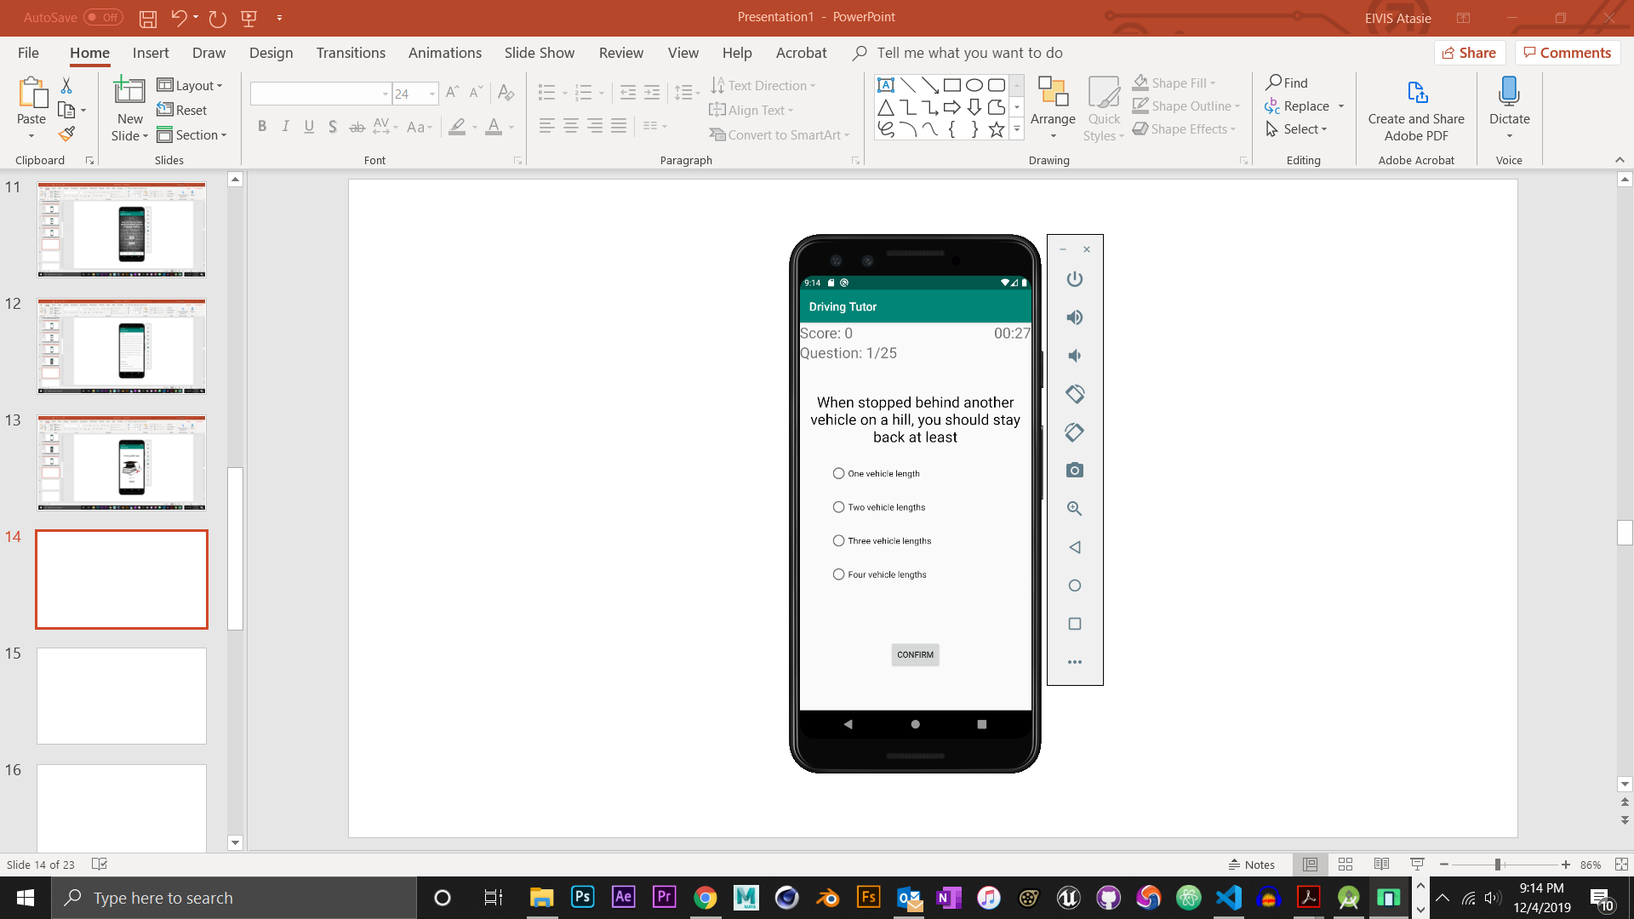

30 seconds per question timer

Here you would be tested with 25 Questions from the information you read in learning section previous to this section

*(device displayed is a Google Pixel 3)*

**Program Workspace**

**-Common Rules**

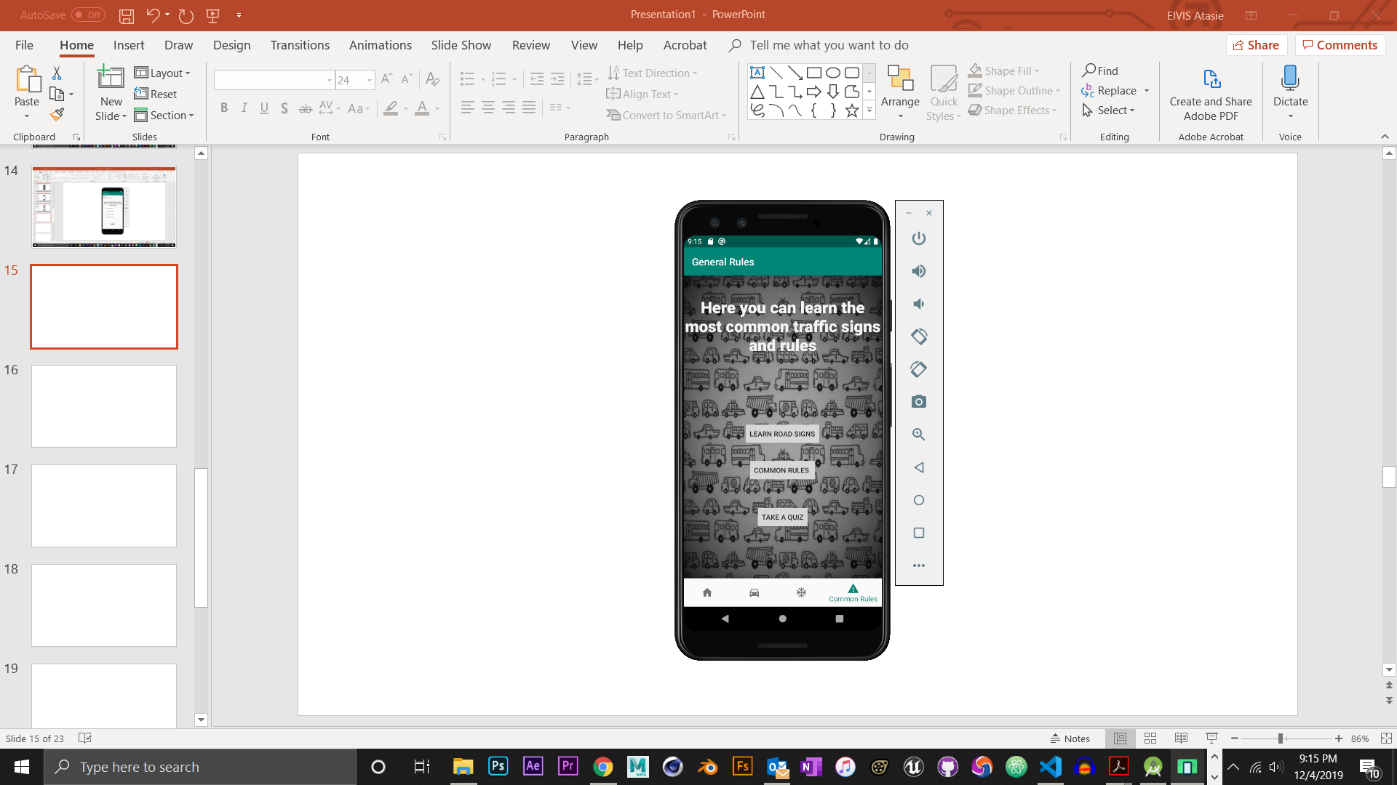

*(device displayed is a Google Pixel 3)*

**Program Workspace**

**-Common Rules**

**-Learn road signs**

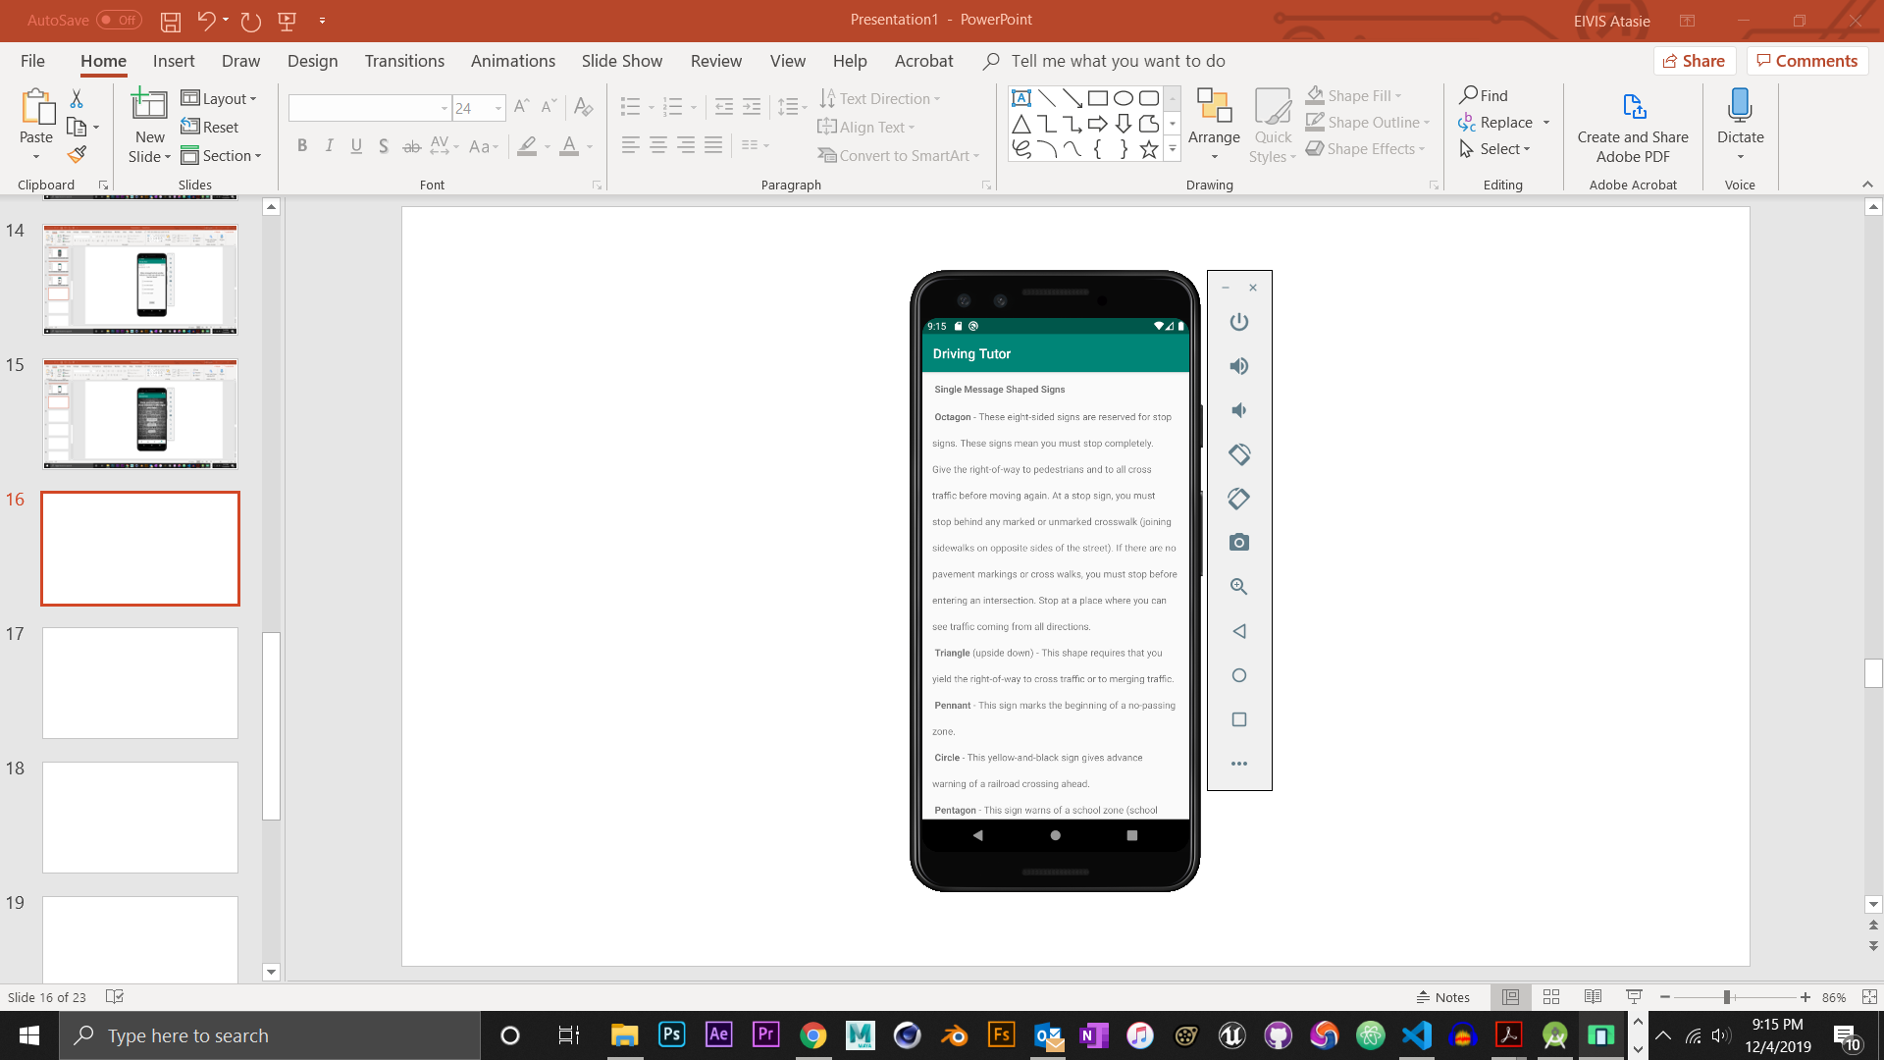

*(device displayed is a Google Pixel 3)*

**Program Workspace**

**-Common Rules**

**-Common rules**

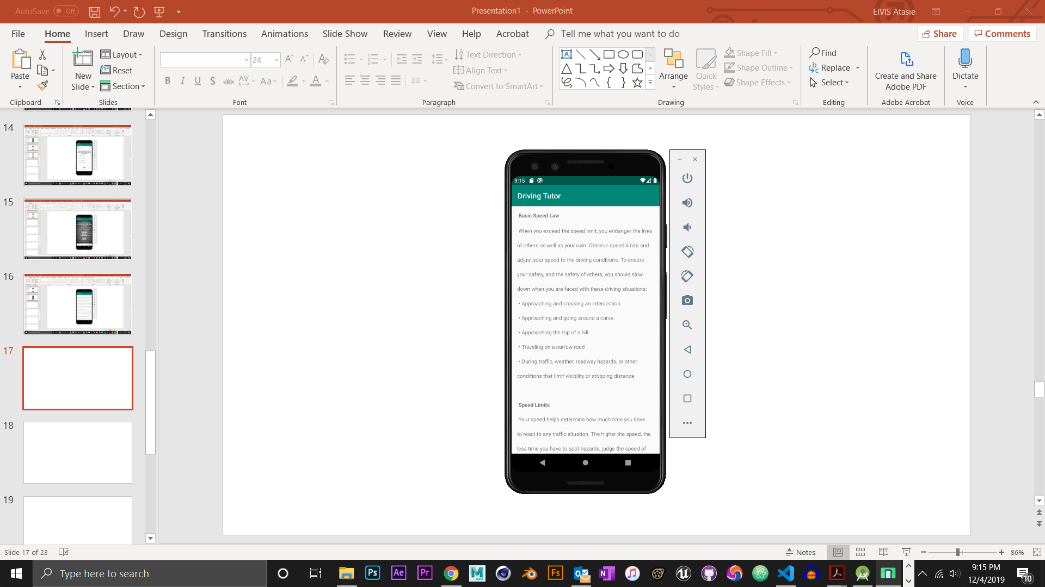

**In this section you will learn common driving rules**

*(device displayed is a Google Pixel 3)*

**Program Workspace**

**-Common Rules**

**-Take a Quiz**

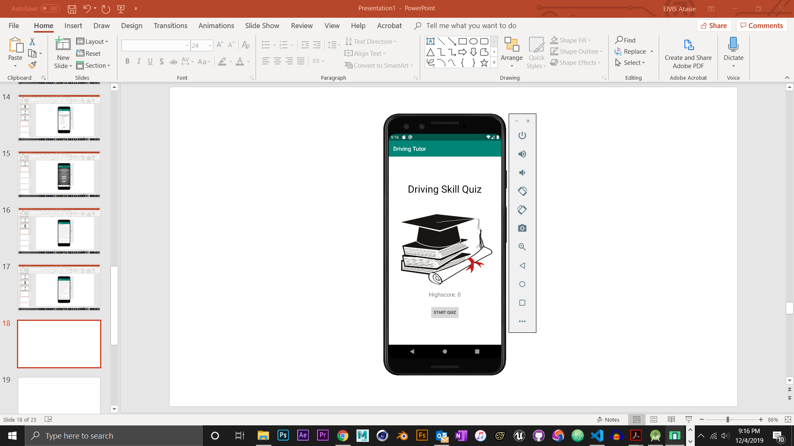 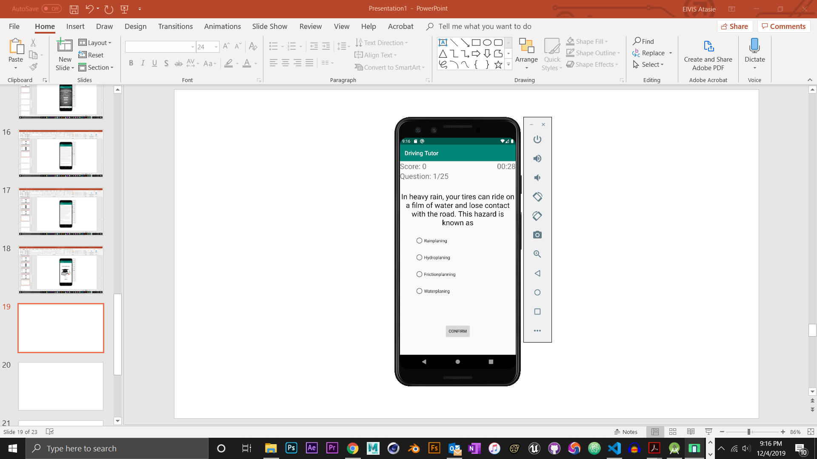

30 seconds per question timer

Here you would be tested with 25 Questions from the information you read in the sections previous to this.

*(device displayed is a Google Pixel 3)*

**THE END**